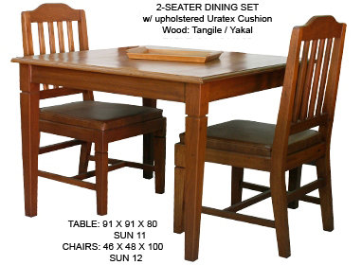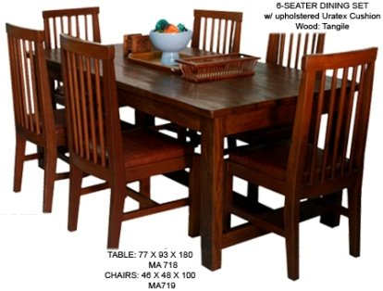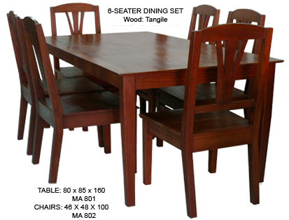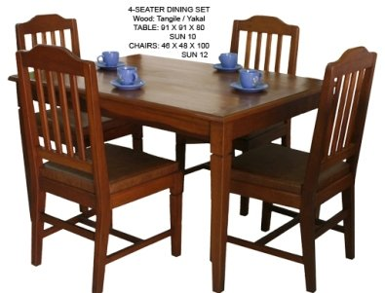

6 Seater Dining Set

MA718- 13,000.00

MA719- 3,500.00

SET- 32,500

2 Seater Dining Set

SUN11- 10,000.00

SUN12- 2,900.00

SET- 15,714.29

6 Seater Dining Set

MA801- 8,470.00

MA802- 3,200.00

SET- 25,000.00

4 Seater Dining Set

SUN 10- 12,900.00

SUN 12- 2,900.00

SET- 24,285.71